1. What are three conclusions we can make about Kickstarter campaigns given the provided data?

I) Higher the goal amount, the tougher it is for the Kickstarter project to meet the goal and be successful. The trend lines points it clearly.

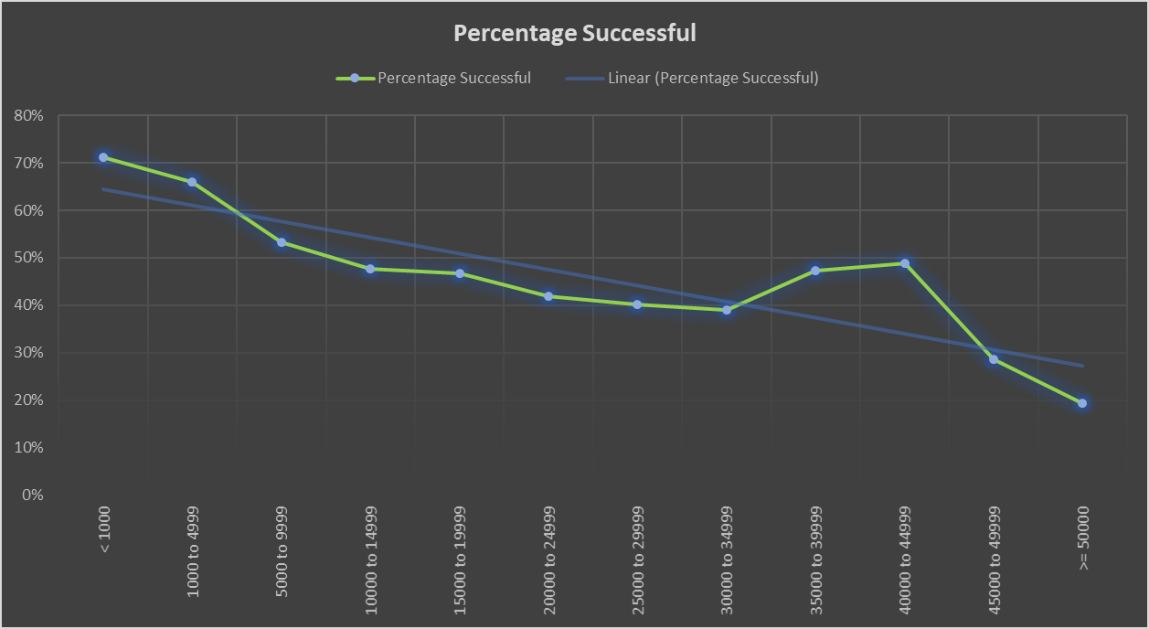

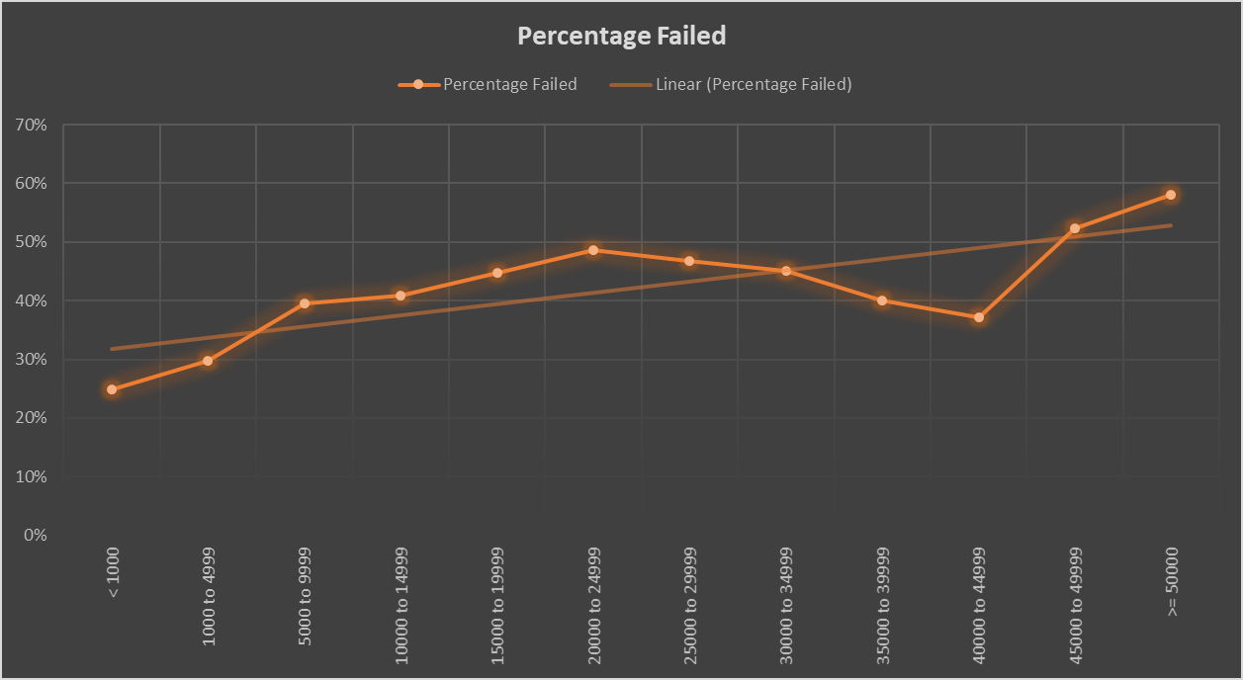

II) As the economy got better after the recession, the number of Kickstarter projects increased implying people are willing to take more risk and backers are willing to support new projects when the overall financial sentiment is positive. The below chart shows a steady trend increase in total number of projects from 2009-2016 (2017 has incomplete data)

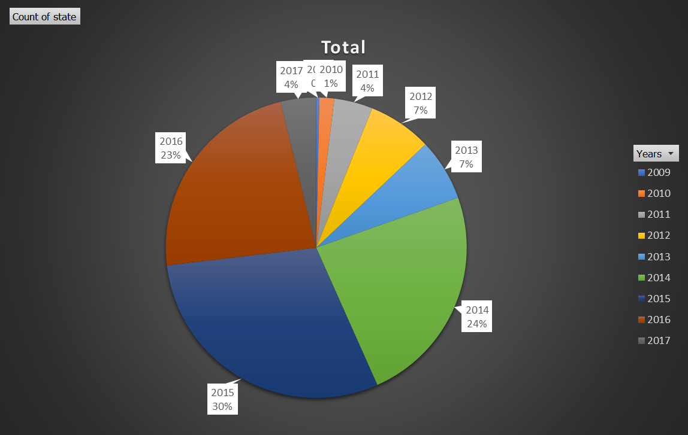

From a different point of view, the number of Kickstarter projects created in a particular year might provide an insight in to the financial well-being of a country/economy. This might not have any relation to the actual project outcome.

III) Successful projects tend to have a higher average donation amount.

In the dataset analyzed, successful projects had higher average donations between $50 and $100 whereas failed projects had majority of average donations between $0 and $50

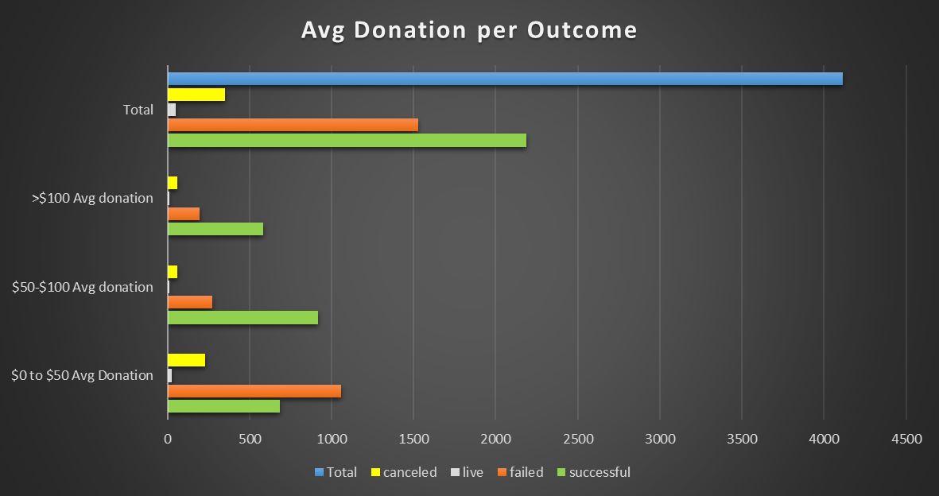

IV) Kickstarter projects related to music are the most successful (success percentage) and the ones related to journalism are the least successful. Food Kickstarter projects are a close second in failure rate unless it’s a small batch project

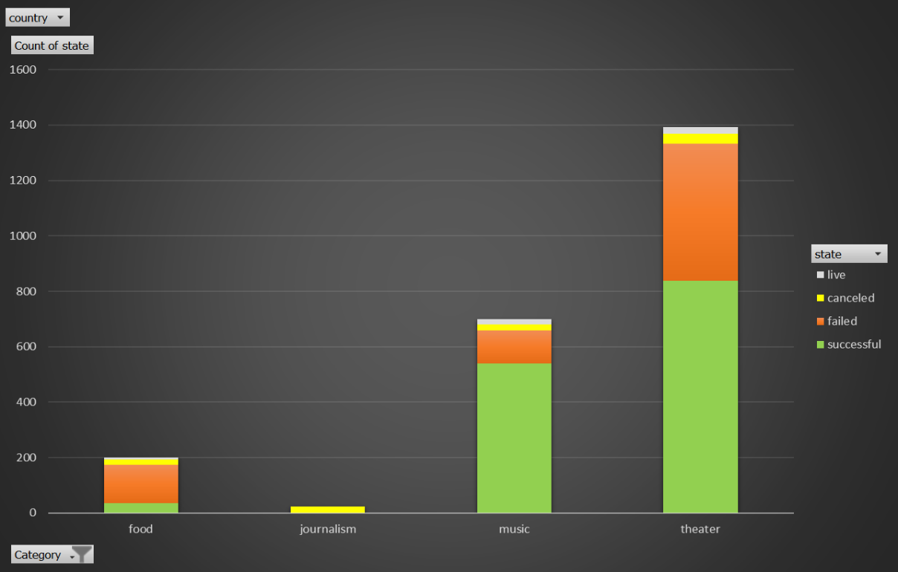

Theatre projects (specifically plays) are high activity, high volume and high demand projects going by the number of projects and that are successful.

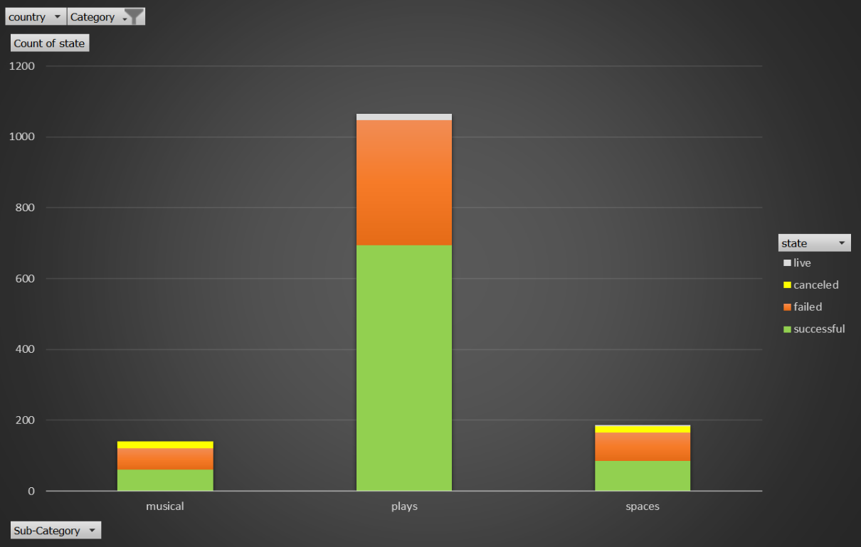

1. What are some of the limitations of this dataset?

Data is incomplete (2017 has projects listed only from the 1st quarter)

Projects which are marked staff pick have a higher success percentage but is it causing a bias among the backers and making the project successful has to be analyzed

Data is skewed (75% data is from US which is not a comprehensive representation of overall demographic coverage)

1. What are some other possible tables/graphs that we could create?

Pie charts (used above)

Bar charts (used above)

Scatter plots (to analyze a trend)

Column charts (similar to bar charts)

Line graphs